Name: Ben Karabinus

**Q1: Lambda in ridge and lasso regression**

1. What is the potential range of lambda?

The potential range lambda is zero to positive infinity.

1. What is true about ridge vs lasso regression when lambda = 0?

In ridge regression if lambda = 0 then the regression equation is just a regular least squares regression. The penalty term is being multiplied by zero. In effect it’s dropped.

1. As lambda gets bigger, what happens to the coefficients? How does this differ between ridge and lasso?

As lambda gets bigger coefficients will shrink towards 0. The main difference between ridge and lasso is that in lasso regression coefficients will shrink all the way to 0. This allows lasso to be used as a variable selection method as well.

1. What is meant by “sets of coefficients” associated with lambda?

“Set of coefficients” associated with a lambda means the set of values for the coefficients when the penalty term (shrink ray) is multiplied by a specific lambda.

Reminder of function that is minimized in each method:

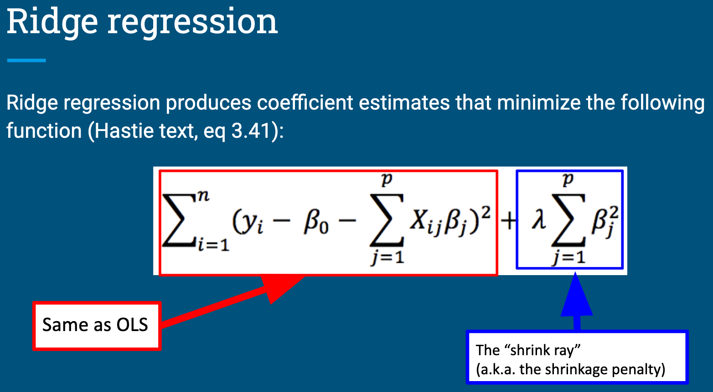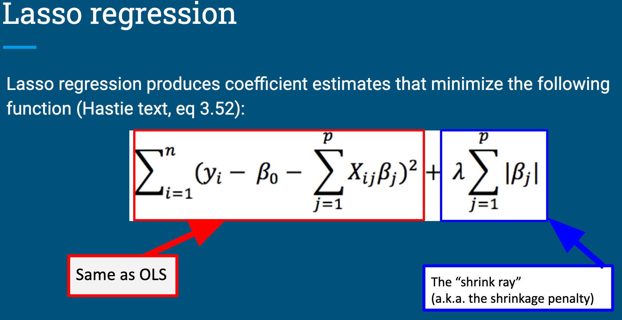

There are questions on the next page – keep going!

**Q2: The glmnet() function**

The answers to the following questions can be found in the glmnet documentation. You can find this by installing the package and typing ?glmnet into the console or by searching online.

There is also a nice introduction to using the package maintained by the developers: <https://glmnet.stanford.edu/articles/glmnet.html> . This may help with understanding how to apply the demonstrations in the async to the problem set.

1. The glmnet() function in the glmnet package can fit both lasso and ridge regression models. Which one does the function perform by default? What change do you need to make if you want to perform the non-default option?

The glmnet() function fits a lasso regression model by default. This is specified by the parameter “alpha.” For lasso alpha = 1. For ridge regression set alpha = 0.

1. The first argument in the function is ‘x’. What should you put here and what form does it need to be in?

X is an input matrix of observation vectors (a matrix of all observations excluding the outcomes). X is a design matrix minus the first column of ones.

1. The second argument in the function is ‘y’. What should you put here and what form does it need to be in?

Y is a vector of outcomes of the same length as X.

1. The third argument in the function is ‘family’. What is the default of this? When would you need to change it?

The default for the family argument is “Gaussian.” This would need to be changed if fitting another type of model such as, logistic regression (family = ‘Binomial”)

1. By default, how many sets of coefficients will be evaluated? What change would you need to make if you wanted to evaluate 500 lambdas?

By default, 100 sets of coefficients will be evaluated (lambda = 100). To evaluate 500 sets of coefficients (lambda = 500) the parameter nlmbda must be set to nlambda = 500.